**Macomb County 4-H Youth Council**

**September 16, 2021**

**Zoom, 6:30pm**

<https://msu.zoom.us/j/92110560486>

**Meeting ID:** 921 1056 0486

**Passcode:** 472169

**Attendance:** David Casto, Cindy Bohm, Liz Barone, Avery Stallmann, Grace Tobey, Morgan Jowett, Angelina Accuso, Katelyn Golembiewski, Michelle Porter

1. **Call Meeting to Order:** 6:36pm
2. What does youth council do? Make decisions for the county 4-H program, plan county-wide events, build leadership skills
3. **Pledge of Allegiance /4-H Pledge:** Morgan led the pledges
4. **Introductions:** Name, grade, 4-H club, If you could only keep 3 apps on your phone what would they be and why? (phone calls and texting will already be on your phone)
5. **Secretary’s Report:** [July 27, 2021.](https://www.canr.msu.edu/macomb/uploads/Meeting%20Miutes%207-27-2021.docx) Angelina moves to accept the minutes. Second. Motion passes.
6. **Treasurer's Report:** Balance as of August 31 is $12,267.65. Expenses $1,797.68. Income: ?   Profit: $683.02 Outstanding items: reimburse Katelyn for t-shirts and reporter badge. Angelina motions to reimburse Katelyn for the badge. Second. Motion passes.
7. **Other Officers and Committees Reports**
   1. **Reporter** - No report
   2. **Awards and Recognition Subcommittee** - 3 people have submitted applications/nominations. Deadline to apply is September 30. Date for awards and recognition event needs to be set. Katelyn will send out a Doodle poll with dates and times to respond to.
8. **Adult Advisors -** Cindy Bohm and Elizabeth Barone
   1. Thank you email to Mr. Jim for serving as a Youth Council Adult Advisor!
9. **Extension Staff –** See upcoming programs and opportunities listed below
10. **Old business**
    1. Coffee Cart and Shavings Sale Fundraisers Wrap-Up
       1. Grace moves to allow Cindy to write checks to those that volunteered for the coffee cart and shavings sale. Second. Motion passes.
          1. Angelina moves to reimburse Ms. Cindy for the purchase of stamps to use to mail checks to clubs and individuals. Second. Motion passes.
       2. Feedback - what went well? What can be improved?
          1. We sold the most water, then gatorade, and coffee sold more in the evening. Next year maybe get more gatorade. Hopefully start earlier next year so we can sell more coffee.
          2. Sold out of shavings.
    2. Thank you cards - include a note to clubs that volunteered with their checks. Morgan will write it and send to Ms. Cindy. Thank you to fairboard. Thank you to Mr. Jim. Katelyn will create e-card for everyone to sign.
11. **New Business**
    1. YC Officer Roles and Responsibilities
    2. Nominations for Officers
       1. President - Morgan nominates herself for President. Angelina moves to close nominations. Second. Motion passes.
       2. Vice President - David nominates himself for Vice President. Grace moves to close nominations. Second. Motion passes.
       3. Secretary - Angelina nominates herself for Secretary. David moves to close nominations. Second. Motion passes.
       4. Treasurer - Grace nominates herself for Treasurer. Angelina moves to close nominations. Second. Motion passes.
       5. Reporter - Avery nominates herself for Reporter. Angelina moves to close nominations. Second. Motion passes.
12. **Adjournment and Next Meeting Date:** Next meeting will be in-person at the MSU Extension Office (21885 Dunham Rd. Suite 12, Clinton Township, MI 48026) on Thursday, October 21st at 6:30pm. A virtual option will be provided for anyone who would like to/needs to Zoom into the meeting. Meeting adjourns at 7:46pm.

**Upcoming Programs/Opportunities:**

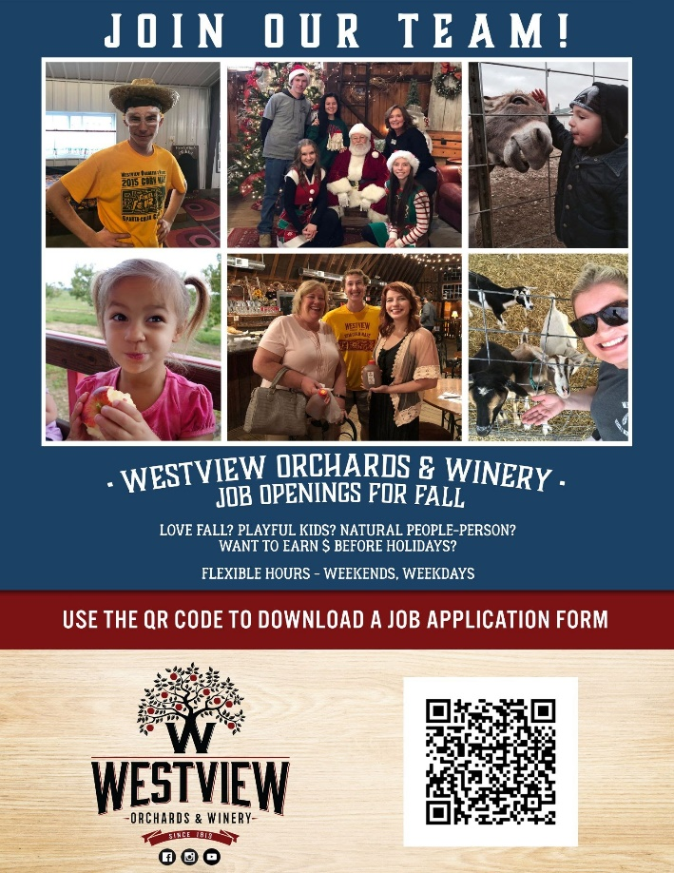

* [**County Awards**](https://sites.google.com/msu.edu/macomb-county-4-h/home) **due September 30th!**
* **4-H Future Squad Programming**
  + Hello Generation Z youth! If you are 12-19 years old and live in Wayne, Oakland, Macomb, Washtenaw, St. Clair, Livingston or Monroe counties, YOU are invited to be a part of the 4-H Future Squad, generously sponsored by the Ralph C. Wilson Jr. Foundation, starting in October. This exciting opportunity will allow you to meet new people, learn life skills to prepare for your future, and earn incentives for participation!  Participate in a variety of topics such as money management, healthy living, stress management, getting along with others, and more!  Additional information, dates and times, and registration details can be found at:<https://www.canr.msu.edu/career_preparation/4-HFutureSquad/>

**What in-person content day would you like to see provided in Macomb County?** Resumes, interviewing, cooking/nutrition, mindfulness, entrepreneurship, Budgeting/financial topics, public speaking, goal setting, time management, leadership (Real Colors Workshop), CPR/first aid, disaster preparedness, etc.